#ASSIGNMENT : 2
#File-Based Contact Book

CODE :-

'''---------------------------------------------------------------
Name: Riju kumar saha
Roll No.:2501940018
MCA(AI & ML)
------------------------------------------------------------------'''

import csv
import json
import os

FILE_CSV = "contacts.csv"
FILE_JSON = "contacts.json"

def add_contact():
name = input("Name: ").strip()
phone = input("Phone: ").strip()
email = input("Email: ").strip()

if not name or not phone or not email:
print("All fields are required.")
return

file_exists = os.path.exists(FILE_CSV)
with open(FILE_CSV, "a", newline="") as f:
writer = csv.DictWriter(f, fieldnames=["Name", "Phone", "Email"])
if not file_exists:
writer.writeheader()
writer.writerow({"Name": name, "Phone": phone, "Email": email})
print("Contact added successfully!")

def view_contacts():
if not os.path.exists(FILE_CSV):
print("No contacts found.")
return
with open(FILE_CSV, "r") as f:
reader = csv.DictReader(f)
contacts = list(reader)
if not contacts:
print("Contact list is empty.")
return
print("\nAll Contacts:")
for c in contacts:
print(f"{c['Name']} | {c['Phone']} | {c['Email']}")

def search_contact():
if not os.path.exists(FILE_CSV):
print("No contacts found.")
return
name = input("Enter name to search: ").strip().lower()
with open(FILE_CSV, "r") as f:
reader = csv.DictReader(f)
found = False
for c in reader:
if name in c['Name'].lower():
print(f"Found: {c['Name']} | {c['Phone']} | {c['Email']}")
found = True
if not found:
print("No contact found.")

def update_contact():
if not os.path.exists(FILE_CSV):
print("No contacts found.")
return
name = input("Enter contact name to update: ").strip().lower()
with open(FILE_CSV, "r") as f:
contacts = list(csv.DictReader(f))
updated = False
for c in contacts:
if c["Name"].lower() == name:
c["Phone"] = input("Enter new phone: ").strip()
updated = True
if updated:
with open(FILE_CSV, "w", newline="") as f:
writer = csv.DictWriter(f, fieldnames=["Name", "Phone", "Email"])
writer.writeheader()
writer.writerows(contacts)
print("Contact updated successfully!")
else:
print("Contact not found.")

def delete_contact():
if not os.path.exists(FILE_CSV):
print("No contacts found.")
return
name = input("Enter name to delete: ").strip().lower()
with open(FILE_CSV, "r") as f:
contacts = list(csv.DictReader(f))
new_contacts = [c for c in contacts if c["Name"].lower() != name]
if len(new_contacts) == len(contacts):
print("Contact not found.")
else:
with open(FILE_CSV, "w", newline="") as f:
writer = csv.DictWriter(f, fieldnames=["Name", "Phone", "Email"])
writer.writeheader()
writer.writerows(new_contacts)
print("Contact deleted successfully!")

def export_json():
if not os.path.exists(FILE_CSV):
print("No contacts found.")
return
with open(FILE_CSV, "r") as f:
contacts = list(csv.DictReader(f))
with open(FILE_JSON, "w") as f:
json.dump(contacts, f, indent=4)
print("Contacts exported to JSON!")

def import_json():
if not os.path.exists(FILE_JSON):
print("No JSON file found.")
return
with open(FILE_JSON, "r") as f:
contacts = json.load(f)
print("\nContacts from JSON:")
for c in contacts:
print(f"{c['Name']} | {c['Phone']} | {c['Email']}")

def main():
while True:
print("\n=== Contact Book ===")
print("1. Add Contact")
print("2. View Contacts")
print("3. Search Contact")
print("4. Update Contact")
print("5. Delete Contact")
print("6. Export to JSON")
print("7. Import from JSON")
print("8. Exit")
choice = input("Enter choice: ").strip()
if choice == '1': add_contact()
elif choice == '2': view_contacts()
elif choice == '3': search_contact()
elif choice == '4': update_contact()
elif choice == '5': delete_contact()
elif choice == '6': export_json()
elif choice == '7': import_json()
elif choice == '8':
print("Goodbye!")
break
else:
print("Invalid choice. Try again.")

if __name__ == "__main__":
main()

OUTPUT :
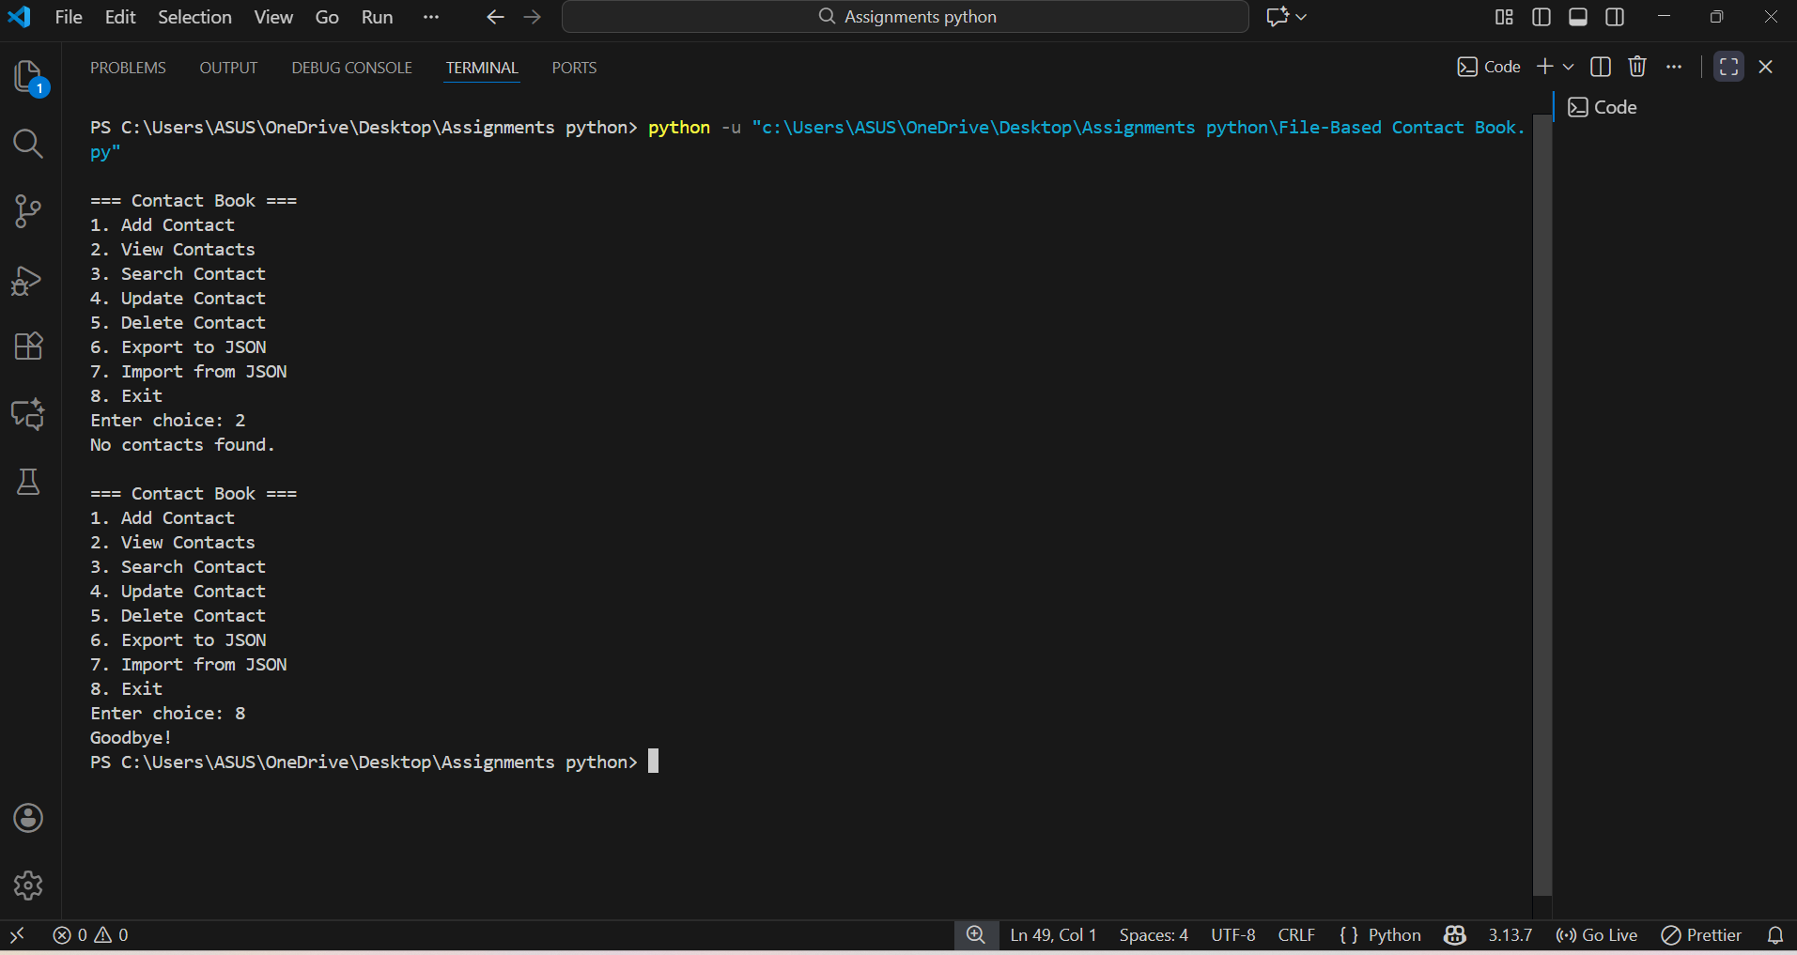
Github : https://github.com/rijusaha8521/Assignment-2-python/upload/main

